http://researchap.com/lalabeharisukla/

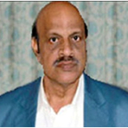

Prof. Lala Behari Sukla – Lifetime Achievement Award – Biotechnology – Research ap
Prof. Lala Behari Sukla – Lifetime Achievement Award – Biotechnology Research Aufau May 11, 2016…
RESEARCHAP.COM

