ABSTRACT

Water is not only one of the most important and basic natural resources on earth but also one of the most vital commodity of our daily life. This natural resource forms the sustenance of all the living organisms. Rain and snowfall are the two natural sources of pure water on earth. The initial stage of the journey of water on earth includes surface run-off in the form of streams, rivers and lakes. These streams, rivers and lakes are the main source of potable water in India. In India many toxic hazardous metals discharged into the river from mining industries, which leads many lethal diseases to human being. So the potable water quality is very significant and vital concern at present as it is related with the present and future health perspective of the human race.

Awareness of health risks associated with unsafe water is still very low among the many rural and urban areas in India. Only about 7% of total Indian people using water purifier. This unhealthy situation of water is not only present in India but also present in many underdeveloped countries. The major reason behind this is the high cost of water purifier. This current study geared towards development of economical and efficient technology for the removal of maximum possible toxic metals and pathogen bacteria.

The work involves the design of portable water purification system using iron impregnated activated carbon (coconut-shell) and other filtration materials. Objective of this work is the removal of iron and arsenic from the drinking water. This study comprises of three phases: a) In the first phase, Activated carbon made from coconut shell was impregnated with Fe³⁺.Then SEM analysis was done to know the texture, orientation and chemical composition of the impregnated activated carbon. Surface area of the impregnated activated carbon was done by BET (Brunauer–Emmett–Teller ) analysis. Iodine value, total pore value, methylene blue value was calculated by ASTM method. b) In second phase, Batch adsorption test was done by taking iron and arsenic sample. The result detailed batch adsorption result were discussed in this study. c) In the third phase, Design of filtration media was done using modified activated carbon, polypropylene filter cloth and manganese modified sand. Then iron and arsenic samples were filtered through the filter media and was analysed by AAS (atomic adsorption spectroscopy).
CONTENTS

Items |  | Page No
Certificate |  | iii
Acknowledgment |  | iv
Abstract |  | v
Content |  | vi-vii
List of Figures |  | viii
List of Tables |  | viii
List of Abbreviations |  | viii
Chapter 1
Introduction |  | 1-7
1.1 | General | 2
1.2 | Objective of The Research | 7
Chapter 2
Literature Review |  | 8-15
Chapter 3
Material Collection |  | 16-18
3.1 | Material Used | 17
Chapter 4
Methodology |  | 19-32
4.1 | General | 20
4.2 | Impregnation of iron on coconut-shell activated carbon | 20
4.3 | Scanning electron microscopic analysis of GAC and Fe-GAC | 20
4.4 | Determination of Iodine value | 23
 | 4.4.1 Procedure | 29
4.5 Surface Area and Total pore value Measurement |  | 27
 | 4.5.1 Procedure | 29

4.6 pH Value |  | 29
4.7 | Batch Adsorption study | 30
Chapter 5
Design of Cartridge |  | 32-33
Chapter 6
Result and Analysis |  | 34-42
Chapter 7 |  | 43-44
7.1 | Conclusions | 44
7.2 | Future scope of study
References |  | 45-47

List of Figures

Figure 3.1

Figure 4.1

Figure 4.2

Figure 4.3

Figure 5.1

Figure 6.1

Figure 6.2

Figure 6.3

Figure 6.4

Figure 6.5

Figure 6.6

Figure 6.7

Figure 6.8

Figure 6.9

Figure 6.10

Figure 6.11

Coconut shell activated carbon | 17
Scanning Electron Microscopy setup | 23
BET analysis machine | 27
pH meter | 30
Model of cartridge using Fe-GAC and Polypropylene | 33
filter cloth
SEM photography of Activated Carbon | 35
SEM photography of Iron impregnated activated | 35
carbon | 35
SEM analysis of presence of chemical component in
activated carbon | 36
SEM analysis of presence of chemical component in
iron impregnated activated carbon | 36
Experimental and theoretical qe versus Ce plots for the | 36
As(v) on Fe-AC | 38
Langmuir isotherm for As(v) adsorption
Freundlich isotherm for As(v) adsorption | 38
Removal efficiency of As(v), C0= 0.6 mg/L, Fe-AC | 39
dose=10mg/L
Effect of adsorbent dose for As (v) removal, contact | 39
time=240min, C0=0.3 mg/L
Removal efficiency of As(V) by modelled cartridge | 40
Removal efficiency of Fe by modelled cartridge

41
41

List of Tables

8 | P a g e

Table 1 | Drinking water standards for trace and toxic metals | 6
 | according to BIS’s manual
Table 2 | Physical properties of GAC and Fe-GAC | 37

9 | P a g e

CHAPTER 1

INTRODUCTION

10 | P a g e

1.1 General:

Water pollution is the main environmental concerns in India, which is the introduction of contaminants into the natural waters that causes adverse changes. Water Pollution is caused due to the discharges of raw domestic sewage and chemical contaminants like chlorine from treated sewage; release of commercial and industrial wastewater into surface waters, intentionally or through spills; release of untreated or semi treated industrial effluents, mining activities; release of waste and contaminants containing chemical fertilizers and pesticides, eutrophication and littering into surface runoff flowing to surface water sources including urban and agricultural runoff, etc. Many water resources have been found polluted and dangerous to human being.

In the developing countries like India, drinking water treatment facilities before supply are not always available. People takes water directly from the untreated source for their domestic use in many parts of the country. Availability of good quality and quantity of water is a threat because of the unplanned urbanization and industrialization.

Continuous exposure to the toxic heavy metals may result in slowly developing physical, neurological and muscular deteriorating processes that mimic Parkinson’s disease, Alzheimer’s disease, muscular dystrophy, and multiple sclerosis. Allergies are common and regular long term contact with some metals or their compounds may even cause cancer. Heavy metals may be absorbed through the skin when they enter into contact with humans in agriculture, pharmaceutical, manufacturing, industrial settings or may enter the human body through food, air and water. Drinking water standards for trace and toxic metals according to BIS’s manual no. 10500-2012 are given below in the table.

11 | P a g e

Table 1 Drinking water standards for trace and toxic metals according to BIS’s manual

 |  | Requirement |  | Permissible Limit in the Absence of
 |  | (Acceptable Limit) |  | Alternative Source
Sr. | Toxic metal
Sr. | Toxic metal | (mg/L) | (µg/L) | (mg/L) | (µg/L)
1 | Total arsenic as As | 0.01 | 10 | 0.05 | 50
2 | Cadmium as Cd | 0.003 | 3 | No relaxation
3 | Total Chromium as Cr | 0.05 | 50 | No relaxation
4 | Copper as Cu | 0.05 | 50 | 1.5 | 1500
5 | Iron as Fe | 0.3 | 300 | No relaxation
6 | Lead as Pb | 0.01 | 10 | No relaxation
7 | Mercury as Hg | 0.001 | 1 | No relaxation
8 | Nickel as Ni | 0.02 | 20 | No relaxation
9 | Zinc as Zn | 5 | 5000 | 15 | 15000

For removing toxic metals from drinking-water resources, there are so many processes available like improved coagulation, membrane systems, zero valent iron (Vaughan and Reed, 2005), ion exchange, adsorption onto activated alumina and other oxyhydroxides (Rau et al., 2003), electrodialysis (Kim and Nriagu, 2000), lime softening, adsorption by metal oxides and photocatalyst adsorbent system (Nakajima et al., 2005). But the technology of Impregnation of iron on activated carbon (Meng et al., 2001; Zhang and Itoh, 2006;) is very operative and promising. The purpose of this research was concentrated on removal of toxic metals from potable

12 | P a g e

water with using of iron-impregnated activated carbon as an adsorbent material and its design for

making a portable filtration system.

1.2Research objective and outline:

- To prepare the cost effective activated carbon and iron impregnated carbon, application of domestic drinking water supply for rural area.

- To characterize activated carbon BET test for specific surface area, Scanning Electron Microscope (SEM) analysis, Batch sorption test of activated carbon-ray

Diffraction(XRD) analysis and pore volume of Iron impregnated activated carbon and normal activated carbon.
- To analyze the different results obtained from impregnated activated carbon.

To use the impregnated activated carbon infiltration of water sample for removal for Arsenic and iron from water supply for rural areas.

13 | P a g e

CHAPTER 2

LITERATURE REVIEW

14 | P a g e

- Franz Krczil(1935) invented the manufacture of hard active carbon of high adsorptive power in the moulded state. The product was a granular or powdered activated carbon.

Activating agents such as phosphoric acid or zinc chloride were impregnated on The organic raw materials like sawdust, peat or lignite and well stirred while being heated to a temperature in excess of 100ºC , and not more than 200 ºC. ,untill the the preliminary carbonized mass assumes a kneadable form.After this preliminary form it was moulded under pressure,baked and activated.

- Ronald S. Joyce, et al. (1965) studied removal of soluble iron compounds from water by a more effective process than the use of activated carbon alone. He impregnated

manganese dioxide to the activated carbon and successfully removed iron compounds from water.

- James O. Knobloch, et al. (1965) studied the removal of metals by activated carbon and more particularly relates to the removal of iron by activated carbon. This invention also

concerns to the decolorizing of aqueous solutions of phthalic acids by contacting said aqueous solutions with activated carbon whose iron content has been reduced.

- Catherine(1988) studied the removal of biological iron from drinking water using oxidation-reduction potential method. During this study a pilot plant was used for

treating raw water with pH 5.7 for biological removal of iron to produce drinking water. Here oxidation-reduction prospective was used as a tool for evaluation and determination of relationship with dissolved oxygenand residual iron concentration within the infiltrate by employing a biological filter.

- Hasan (1990) studied the contact aeration for iron removal method. The removal of iron process utilized the catalytic effect of ferric iron. Again in this experiment it was

theoretically demonstrated that by controlling high concentration of ferric iron, the volume of the aeration tank can be significantly reduced and it was according to the

15 | P a g e

oxygenation rate equation. Ferric iron is very much operative in decreasing the reactor volumes at lower pH values. It is proposed to recycle the ferric sludge to keep the high ferric iron concentrations in the reactor.

- Ken K. Robinson (1990) studied granulation of activated carbon powders. More particularly, this invention relates to a process for spherically agglomerating activated

carbon powders and to the granulated product produced thereby, which product is particularly useful for water treatment. At least about 50% of the carbon powder has a surface area of from about 2800 to about 3500 m²/ gm, an iodine number of from about 2500 to about 3500 mg/gm, a total pore volume of from about 1.0 to about 2.8 cc/gm, and a bulk density of from about 0.27 to about 0.32 gm/cc. The granules are activated by treatment with steam to provide granules having particle diameters of from about 017 to about 0-71 mm, and pore size distribution and adsorptive capacity essentially unchanged from that of the carbon powder.

- William, et al. (1992) studied the removal of iron during water treatment by the influence of dissolved organic carbon. He used the iron removal process by oxidation

and coagulation method. Humic and fulvic acids, tannic acid and oxalic acid were estimated in the organic content. Potassium permanganate, chlorine dioxide and free chlorine were used as oxidizing agent.

- Thomas S. Farris, et al. (1992) studied method of making a granular char from coconut shells so that the char is especially well adapted for conversion into carbon molecular

sieves. In another aspect it relates to a method of making a carbon molecular sieve from coconut shell material.

- Dong, et al (1992) conducted experiments on surface coatings were taken on glass slides within the oxic surface waters of Cayuga lake and Hydroxylamine hydrochlorid

was used to selectively remove Mn oxides, sodium dithionite was used to remove Mn

16 | P a g e

and Fe oxides, 10% oxalic acid was used to remove metal oxides and organic materials and were wont to assess the relative contributions of Fe, Mn adsorption by the surface coating materials. An additive adsorption model based on Pb sorption isotherms for laboratory substitutes for Mn, Fe and al oxides and defined biological elements predicts the projected Pb distribution between surface coating components with that previously.

- Tomotada (2001) studied the Current bioremediation practice and perspective. In the method he used in-situ fluorescence hybridization (FISH), in situ PCR, and quantitative

PCR for removal of contamination by bioremediation .In this method the detection and reorganization of bacteria and pathogens is very vivid and these are being directly related to the rate of degradation of contaminants.

- Wang, et al. (2003) studied the removal of heavy metal ions from water using different adsorbents with marginal cost. For removal of heavy metal ions like cobalt and zinc

from ground water he used different low cost adsorbents like Fe2O3, Fe3O4, FeS, steel wool, Magnesium pallets, Copper pallets, Zinc pallets, Aluminum pallets, Iron pallets, coal, GAC.

- Ronald L. Vaughan et al. (2004) studied As(V) removal onto a iron oxide impregnated activated carbon (FeAC) using the surface complexation model (SCM) approach. He

stated that As(V) removal by FeAC was due to the impregnated Fe oxide, not the base carbon material and was a strong function of pH.

- Choo, et al. (2005) studied the removal of iron and manganese in ultra filtration and also the process of membrane fouling. He also tested to remove the residual chlorine

due to pre-chlorination which is opted as a convenient option for safe drinking water. The membrane fouling was caused due to the oxidation of iron and manganese which was also visualized thoroughly at microscopic level and the steps for eradicating the degradation of membrane were proposed.

17 | P a g e

- Takerlekkopoulou, et al. (2006) studied the physio-chemical and biological iron removal from potable water. He used the technique of trickling filter and constructed a

model for it including the pilot-testing. The main mechanism was physio-chemical and biological oxidation of Fe. The complete chemical reaction and extent of each oxidation was studied. Experimentation was done with specified temperature, optimum feed iron concentration and volumetric flow rate. First order kinetics and Monod-type kinetics was observed in physiochemical and biological oxidations respectively.

- Gupta, (2006) studied the non-conventional low-cost adsorbents for dye removal. He studied an extensive number of adsorbent for filtration and in the review he showed the

critical analysis of these materials, characteristics, advantages, limitations and mechanisms of adsorption. He used activated carbon of agricultural solid waste, industrial by product,clay and materials containing silica.

- Bordoloi, et al. (2007) studied the removal of iron from water using the ash produced from banana residue [14, 15, and 16].Ashes from different materials i.e. dry banana

leaf, pseudo stem, rind, bamboo, rice husk were produced by controlled combustion. The mechanism of removal includes oxidation of iron at high pH or alkaline medium produced by potassium present in banana due to subsequent formation of potassium hydroxide. The study included analysis of chemical composition of banana ash and its efficiency in removal of iron from prefabricated water. Further it has been used in a low cost domestic water purification model in which after treated with ash, the water is being filtered with a cotton cloth and being used for drinking.

- Chen et al. (2007) studied the removal of arsenic from drinking water the by iron impregnated activated carbon. He stated that Oxyanionic arsenic species such as

arsenate and arsenite adsorb at the iron oxyhydroxide surface by forming complexes with the surface sites.

18 | P a g e

- P. Mondal et al. (2007) studied on removal of arsenic from a contaminated ground water (simulated) by adsorption onto Fe3+ impregnated granular activated carbon (GAC-Fe).

Along with arsenic species in the water sample, Fe2+, Fe3+ and Mn2+ have also been considered. He also compared untreated GAC with GAC-Fe and discussed the effects of adsorbent dose, particle size of adsorbent and initial arsenic concentration on the removal of As(T), As(III), As(V), Fe2+, Fe3+ and Mn2+.The % removal of As(T), As(III), As(V), Fe, and Mn were ∼95%, 92.4%, 97.6%, 99% and 41.2%, respectively when 8 g/l GAC-Fe was used at the As0 value of 200 ppb.

- Paul Sylvester, (2008) studied a method for reducing a contaminant using a hydrous or hydrated iron oxide (HFO) from a fluid stream with impregnated activated carbon

sorbent, contacting at least a portion of the sorbent with the fluid stream, thus obtaining a treated fluid stream having a reduced contaminant level.

- Wagh et al. (2010) studied the process for making activated carbon having BET surface area up to 2000 m² /g with pore diameter in the range 17-21Å appropriate for fabricating fuel cell and ultracapacitor electrode from coconut shell by treating carbon granules

made from coconut shells with chemical activating agents like Zinc chloride or potassium hydroxide at the room temperature range 500-800º C. in a dynamic flow of gases like N2 or CO2 for 6-24 h followed by a specific cooling pattern to room temperature.

- Ganvir, et al. (2011) studied the fluoride removal by aluminum hydroxide coated Rice husk ash [12, 13] from ground water. For activating the RHA surface which forms a

complex with fluoride ion in water and accelerates the process of removal activated aluminum hydroxide has been used. RHA was found by controlled burning of dry and crushed rice husk and treating with hydrochloric acid before activation.

19 | P a g e

- Chaturvedi, (2012) studied the removal of iron for safe drinking water. He used the methods of iron removal from drinking water such as electro coagulation; oxidation

filtration, ion exchange, lime softening, adsorption by activated carbon, BIRM media, Anthracite [1],green sand, pebble and sand mixture, ultra filtration etc have been discussed.

- Simonis (2012) studied the production of a low-cost ceramic water filter and filteration system for the elimination of common pathogenic bacteria and suspended solids. A

micro porous ceramic water filter in which clay was mixed with rice husk in a ration 2:1 by weight and a cylindrical shaped filter was manufactured by tradition oven drying and then burning in kiln at specified sintering temperature. After being coated with silver nitrate solution for preventing the growth of microbes, the filter was tested for removal of suspended solids and pathogens.

- Xiaohong Fang et al. (2013) studied chemical oxidative polymerization of aniline monomers with GAC as the supporting materials to fabricate Polyaniline/coconut

shell–activated carbon (PANI/GAC) composites. These equipped PANI/GAC composites were characterized by scanning electron microscopy, N2 adsorption-desorption analysis, and Fourier transform infrared spectroscopy. The effects of various parameters, including aqueous pH, contact time, the initial concentration of Cu(II), and temperature (288–323⁰ K) on the Cu(II)’s adsorption, were investigated in detail.

- Ting chao Yu et al. (2014) modified granular activated carbon with various concentrations of ferric chloride (FeCl3) solution to improve the removal efficiency of

antimony(III). A laser particle size analyzer analyzed the characteristics of granular-activated carbon (GAC) modified and specific surface area tests (BET). The effect of different factors including pH, adsorbate concentration, adsorbent dosage, contact time and temperature on the static adsorption were investigated.

20 | P a g e

CHAPTER 3

MATERIAL COLLECTION

21 | P a g e

3.1 Materials used:

Activated Carbon: Activated carbon is the charcoal that has been heated and treated to increase its adsorptive power. It is a microcrystalline, non-graphitic arrangement of carbon.. Activated carbons are used in the purification of water by the adsorption of dissolved or dispersed substances from water due to it’s large specific surface area typically in the range of 400 to 2500 m2/ g. Commercial grades of activated carbon are designated as liquid-phase adsorbents. Liquid-phase carbons generally may be powdered, granular, or shaped. The adsorption capacity and rate of adsorption depend to a large extent upon the internal surface area and pore size distribution in relation to the dimensions of the adsorbate to remove. For purification the adsorption capacity and the adsorption rate must be as high as possible. Here coconut shell activated carbon is used.

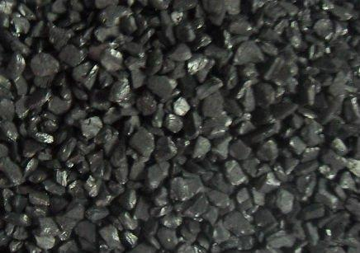

Fig.3.1 Coconut shell activated carbon

22 | P a g e

Ferric Chloride(Fe2Cl3):Ferric chloride is used for impregnation of iron on the Activated carbon.

TriSodium Arsenate (Na3AsO4.12H2O):TriSodium Arsenate is used to calculate the adsorption of As by impregnated activated carbon. Arsenic is a major heavy toxic metal present in water and it is difficult to remove from water by filtration. So in this experiment Arsenic is being used.

23 | P a g e

CHAPTER 4

METHODOLOGY

24 | P a g e

4.1General:

In this chapter, the detail method of impregnation of iron on activated carbon and various tests performed on it were given.

4.2 Impregnation of iron on coconut-shell activated carbon:

The coconut shell activated carbon was bathed three times in deionized water. It is then dried at 110°C over night and cooled in a desiccator. The AC was then sieved using IS standard sieves in the range of 1mm-2mm. Coating of iron on the AC was carried out by impregnation method and thermo-chemical reactions with using of 0.1M FeCl3 solution. pH was adjusted to ~8.5 by addition of NaOH and HCl (0.1N) solution in this process. To obtain a uniform mixture, the AC granules were agitated thoroughly in FeCl3 solution. The AC to iron salt solution ratio was 1:10 and the suspension temperature was organized on 70°C. The suspension was then filtered after 24 hours. The solid phase was dried over night at 120°C and then cooled to room temperature followed by washing it thoroughly with deionized water until a clear supernatant was found. The washed granules were then dried at room temperature to be used as iron-impregnated activated carbon (Zhang et al., 2007). The analysis of solid structures of Fe-AC were done using scanning electronic microscopy (SEM).

Various tests were done on the iron impregnated activated carbon prepared in the laboratory. The tests performed in the laboratory were given below:

4.3Scanning electron microscopic analysis of GAC and Fe-GAC:

Scanning electron microscope (SEM) gives pictorial details of a sample by scanning it with a high-energy beam of electrons in a raster scan form. The electrons intermingle with the atoms that structures the sample producing signals that contain information about the sample's surface topography, composition and electrical conductivity. Secondary electrons, back-scattered

25 | P a g e

electrons (BSE), characteristic X-rays, light (cathode luminescence), specimen current and transmitted electrons signals are produced by a SEM. The signals results from intermingle of the electron beam with atoms at the surface of the sample. In the most general detection mode, secondary electron imaging or SEI, the SEM can yield very high-resolution images of a sample surface, figuring details less than 1 nm in size. A large range of magnifications is possible, from about 10 times (about equivalent to that of a powerful hand-lens) to more than 500,000 times, about 250 times the magnification limit of the best light microscopes. Backscattered electrons (BSE) are beam electrons that are reflected from the sample by elastic scattering. BSE are often used in analytical SEM along with the spectra produced from the characteristic X-rays. Because the intensity of the BSE signal is strongly associated to the atomic number (Z) of the specimen, BSE images can provide information about the delivery of different elements in the sample. When the electron beam removes an inner shell electron from the sample typical X-rays are emitted, causing a higher energy electron to fill up the shell and releases energy. To identify the composition and measure the abundance of elements in the sample, these characteristic X-rays are used. In a typical SEM, an electron beam is thermionically emitted from an electron gun fixed with a tungsten filament cathode. Tungsten has the highest melting point and lowest vapour pressure of all metals. Because of this Tungsten is mainly used in thermionic electron guns, thereby allowing it to be heated for electron emission, and because of its low cost. Other types of electron emitters include lanthanum hexaboride (LaB6) cathodes, which can be used in a standard tungsten filament SEM if the vacuum system is advanced and field emission guns (FEG), which may be of the cold cathode type using tungsten single crystal emitters or the thermally-assisted Schottky type, using emitters of zirconium oxide. The electron beam, which has an energy ranging from 0.5 keV to 40 keV, is focused by one or two condenser lenses to a spot about 0.4 nm to 5 nm in 30 diameter. The beam passes through pairs of scanning coils or pairs of deflector plates in the electron column, mainly in the final lens,

26 | P a g e

which deflect the beam in the x and y axes so that it scans in a raster manner over a rectangular area of the sample surface. When the primary electron beam interacts with the sample, the electrons lose energy by frequent random scattering and absorption within a teardrop-shaped volume of the specimen known as the interaction volume, which extends from less than 100 nm to around 5 µm into the surface. The size of the interaction volume relies on the atomic number of the specimen, electron's landing energy and the specimen's density. The energy exchange between the electron beam and the sample results in the reflection of high-energy electrons by elastic scattering, emission of secondary electrons by inelastic scattering and the emission of electromagnetic radiation, each of which can be detected by specialized detectors. The beam current absorbed by the specimen can also be found and used to make images of the distribution of specimen current. To amplify the signals which are displayed as variations in brightness on a cathode ray tube, electronic amplifiers of different types are used. The raster scanning of the CRT display is coordinated with the beam on the specimen in the microscope and the subsequent image is therefore a distribution map of the intensity of the signal being radiated from the scanned area of the specimen. The image is digitally captured and displayed on a computer monitor and saved to a computer's hard disk. Magnification in a SEM can be controlled over a range of up to 6 orders of magnitude from about 10 to 500,000 times. SEMs may have condenser and objective lenses, but their function is to focus the beam to a spot, and not to image the specimen. In a SEM, as in scanning probe microscopy, magnification results from the ratio of the dimensions of the raster on the specimen and the raster on the display device. Assuming that the display screen has a fixed size, higher magnification results from reducing the size of the raster on the specimen, and vice versa. Magnification is therefore organised by the current brought to the x, y scanning coils, or the voltage brought to the x, y deflector plates, and not by objective lens power.

27 | P a g e

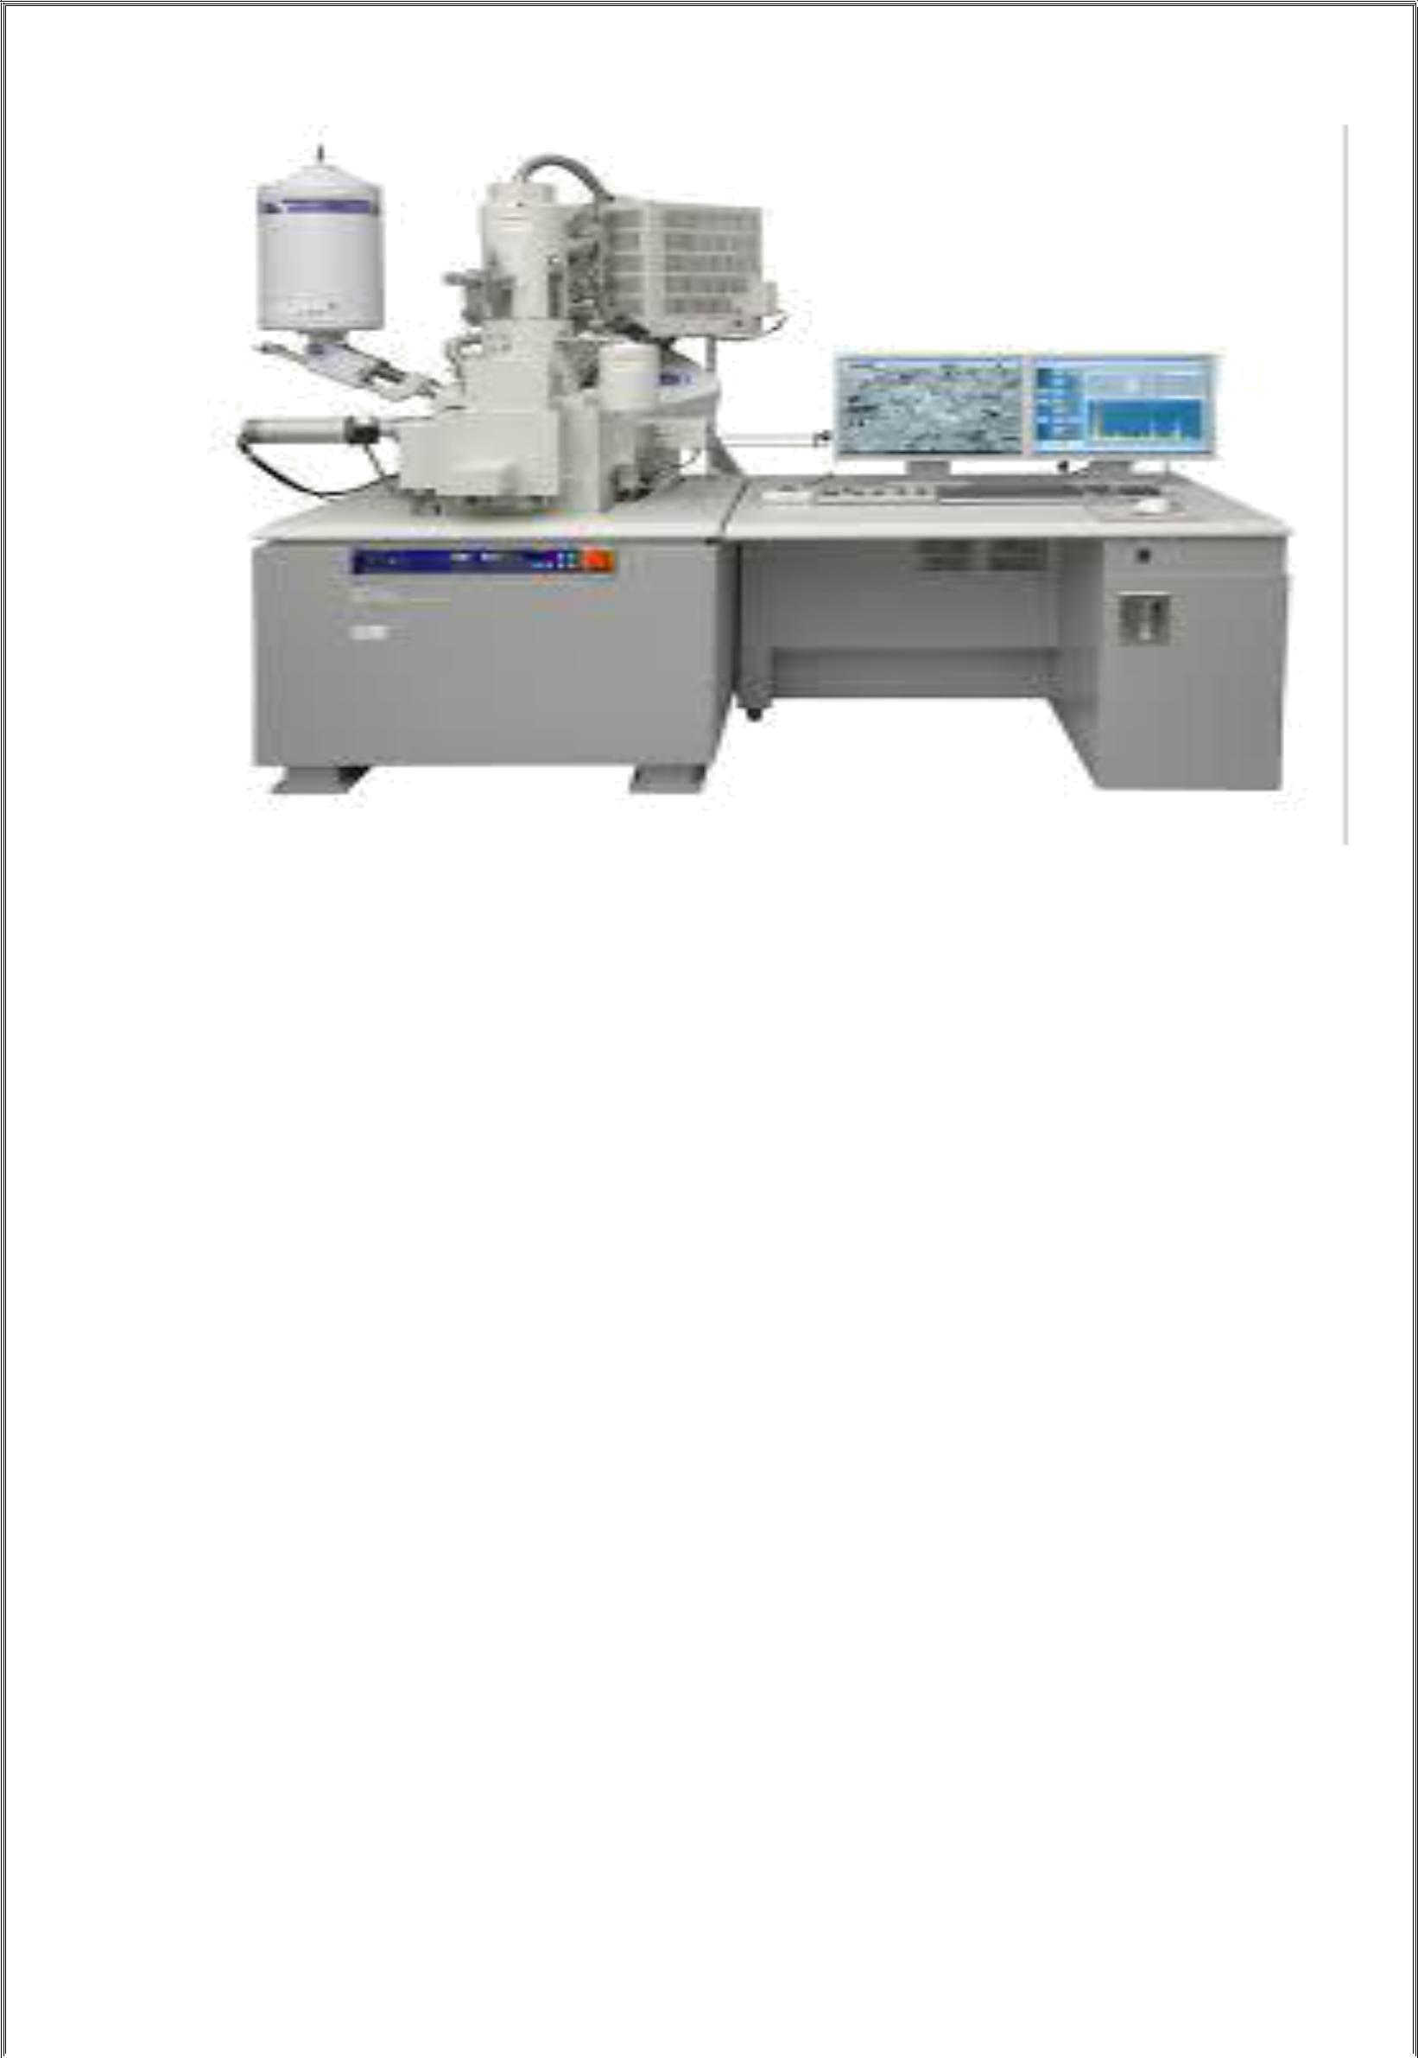

Fig4.1. Scanning Electron Microscopy setup

4.4 Determination of Iodine value (ASTM D4607–14):

This test method determine the relative activation level of unused or reactivated carbons by adsorption of iodine from aqueous solution. The amount of iodine absorbed (in milligrams) by 1 g of carbon using test conditions listed herein is called the iodine number.

The iodine number is a comparative indicator of porosity in an activated carbon. Iodine number may be used as an approximation of surface area for some types of activated carbons (ASTM C819). However, it must be realized that any relationship between surface area and iodine number cannot be generalized. It varies with changes in carbon raw material, processing conditions, and pore volume distribution (ASTM D2652).

4.4.1 Procedure:

Grind a specific of GAC and Fe-GAC each so that 60% of the wt. will pass through 45 micron test sieve and 95% of the wt. will pass through 150 micron test sieve. Dry the carbon samples
28 | P a g e

and then cool them to room temperature in a desiccator. Determination of iodine number requires an estimation of three carbon dosages. Carbon dosage may be estimated as follows:

M= [A-(DF) (C) (126.93) (50)] / E

Where:

M = carbon, g,

A = (N2) (12693.0),

DF = dilution factor (see 11.2.1),

C = residual iodine, and

E = estimated iodine number of the carbon.

Weigh three appropriate amounts of dry carbon to the nearest milligram after estimating carbon dosages. Transfer each weighed sample of carbon to a clean, dry 250-mL Erlenmeyer flask furnished with a ground glass stopper. Pipet 10.0 mL of 5 wt % HCl solution into each flask containing carbon. Stopper each flask and spin gently until the carbon is completely moistened. Loosen the stoppers to opening of the flasks, place on a hot plate in a fume hood, and bring the contents to a boil. Allow to boil gently for 30 seconds to remove any sulphur. Remove the flasks from the hot plate and then cool to room temperature.

Pipet 100.0 mL of 0.100 N iodine solution into each flasks. Normalize the iodine solution just prior to use. Stumble the addition of iodine to the three flasks so that no delays are come across in controlling. Immediately stopper the flasks and agitate the contents briskly for 30 seconds. Quickly filter each mixture into a beaker by gravity through one sheet of folded filter paper. Use the first 20 to 30 mL to rinse a pipet for each filtrate. Reject the rinse portions. Use clean beakers to collect the rest of the filtrates. Mix each filtrate by spinning the beaker and pipet 50.0 mL of each filtrate into a clean 250-mL Erlenmeyer flask. Titrate each filtrate against

29 | P a g e

standardized 0.1 N sodium thiosulfate solution until the solution is a pale yellow. Add 2 mL of the starch indicator solution and continue the titration with sodium thiosulfate until a colourless solution formed. Record the volume of sodium thiosulfate used.

Calculation:

Two calculations are needed for each carbon dosage, as X/M and C.

To calculate the value of X/M , first derive the following values:

A=(N2) (12693.0)

Where,

N2 =iodine, N

B=(N1) (126.93)

Where,

N1 =Sodium Thiosulphate, N

DF= (I+H) / F

Where,

DF=dilution factor

I=iodine, ml

H= 5% of HCL used, ml

F=filtrate, ml

For example, if 10 mL of HCl and 50 mL of filtrate are used:

30 | P a g e

DF = (100 + 10)/50 = 2.2.

Calculate the value of X/M as follows:

X/M= [A- (DF) (B) (S)] / M

Where,

X/M= iodine adsorbed per gram of carbon, mg/g,

S= Sodium thiosulphate, ml , and

M= carbon used, g.

Calculate the value of C as follows:

C= (N1.S) / F

Where,

C= residual filtrate, N,

N1=Sodium thiosulphate, N, and

F=filtrate, ml.

4.5 Surface Area and total pore value measurement:

Nitrogen isotherms at 77 K were measured in a surface area analyser Quantachrome Autosorb-1 MP. Data were analyzed for BET area, total pore volume, micropore volume and average pore width. Surface areas were calculated according to the BET method (F. Rouquerol et al.). Total pore volumes were determined by the equipment at the highest relative pressure (P/P0 ~ 1). To measure micropore volume adsorption data were analyzed by the Dubinin–

31 | P a g e

Radushkevich equation and Based on the total pore volume and surface area average pore widths were calculated.

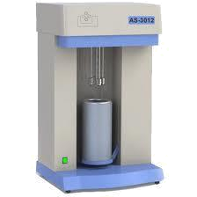

Fig.4.2 BET analysis machine

The BET equation is given by:

1/v [(P0/P)-1]=(c-1) (P/P0)/(vmc)+1 / (vmc)

Where,

P0=Saturation pressure of the adsorbate

P = Equilibrium pressure of adsorbate

v = Volume of gas adsorbed

vm= volume of the gas adsorbed by the monolayer

32 | P a g e

c = BET constant given by exp (EI-EL)

EI=Heat of adsorption for the first layer

EL=Heat of adsorption for higher layers

A plot of 1/v [(P0/P)-1] v/s (P/P0) is obtained from the BET analysis. From the slope and intercept of the line, vm and c are obtained. Surface area S of the solid sample is given by

S= (vmNs)/(vx)

N=Avogadro’s number

S= adsorption cross section of the gas being adsorbed

v = molar volume of the gas being adsorbed

x = mass of the adsorbent

4.5.1 Procedure:

A small amount of the AC and Fe-AC samples were taken in the tube and the tube was placed in a dewar containing liquid nitrogen. Initially the samples were degasified to remove the impurities and gases. Then gaseous nitrogen was passed through the samples and based on adsorption of the gas, the surface areas of the samples were calculated.

4.6 pH value:

pH was determined using the standard method ASTMD 3838-80. 1g activated carbon of coconut shell sample was put in a conical flask and 100ml distilled water was added to it. The mixture was stirred for 1hour. pH readings were then taken using pH meter. Repeat the procedure for Fe-AC.

33 | P a g e

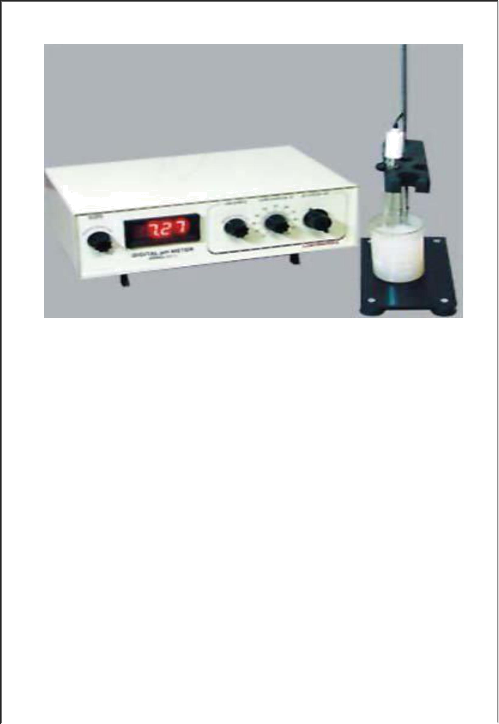

Fig.4.3 pH meter

4.7 Batch adsorption study(As(V)):

Batch adsorption tests were conceded in room temperature (25ºC) with the shaker set at 120 rpm. Starting with 100 mL flasks, comprising several amount of adsorbent (0, 5, 10, 13, 15, 20 and 25 g/L). Na3AsO4·12H2O was then added into a conical flask and the volume was made up to 100mL with water of known concentration (300 and 600 μg/L Arsenate). The flasks were then shaken for 24 h until it reach equilibrium and the supernatant was filtered through a 0.45 μm filter membrane and analyzed to find Arsenic concentration. Arsenic concentrations were measured by Atomic Absorption Spectroscopy (AAS). It was determined that 2.5 hour was long enough to attain the equilibrium from initial kinetic experiments. The arsenic removal efficiency and amount of arsenic adsorbed on the adsorbent were calculated by Eqs.1 and 2, respectively.
E= ^{0−Ce}_{C0} x100
Q_{e=}^{C0−Ce}_{Wm} xV

Where E=removal efficiency

Qe=adsorption amount (mg/g)

C0= concentrations of As in the initial solution

34 | P a g e

Ce = concentrations of As supernatant after adsorption

V=volume of solution (L)

Wm= adsorbent mass(g)

The Langmuir and Freundlich equations were used to describe the equilibrium between adsorbate and adsorbent which can be represented as
Ce | = | 1 | + | C0
Qe | = | Qmax.b | + | Qmax

Log Qe=Log k+(1/n)Log Ce

35 | P a g e

CHAPTER 5

DESIGN OF CARTRIDGE

36 | P a g e

Design of filtration cartridge using Fe-GAC:

The filtration cartridge was designed using Fe-GAC and polypropylene filter cloth.

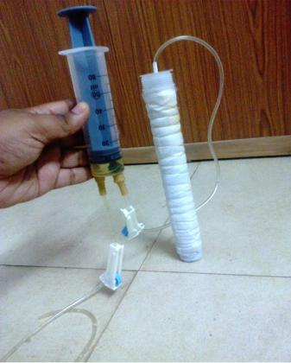

Fig.5.1 Model of cartridge using Fe-GAC and Polypropylene filter cloth Length of the cartridge=23.5 cm

Outer diameter of the cartridge= 2.5 cm Inner diameter of the cartridge= 2 cm Total Activated carbon used=50 gm Polypropylene filter cloth used= 5µ

37 | P a g e

CHAPTER 6

RESULTS AND ANALYSIS

38 | P a g e

6.1 Scanning electron microscopic analysis of GAC and Fe-GAC:

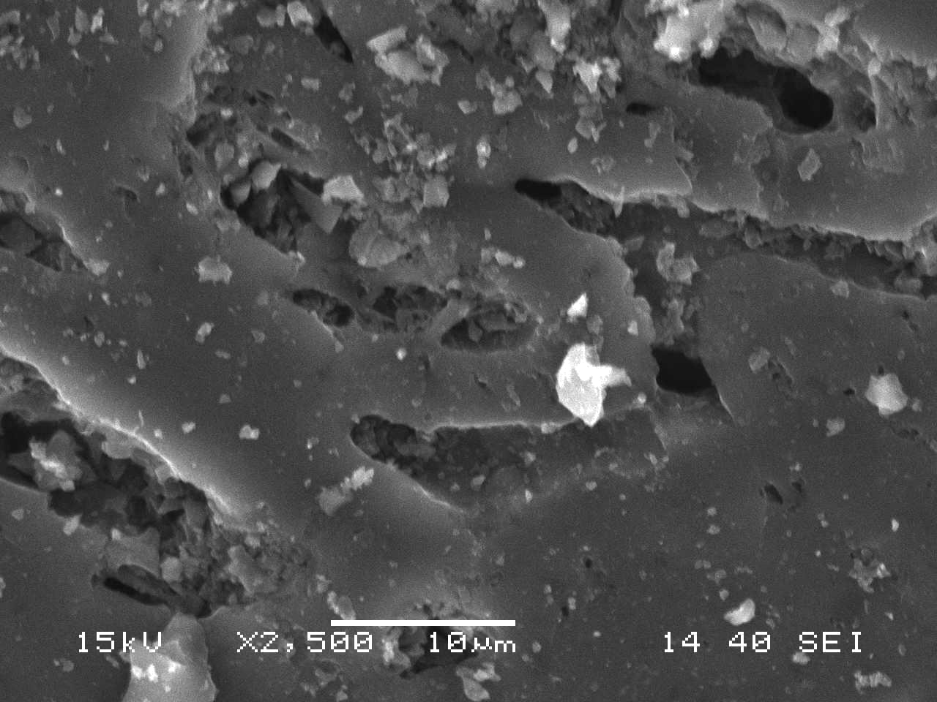

Fig.6.1 SEM photography of Activated Carbon (coconut-shell)
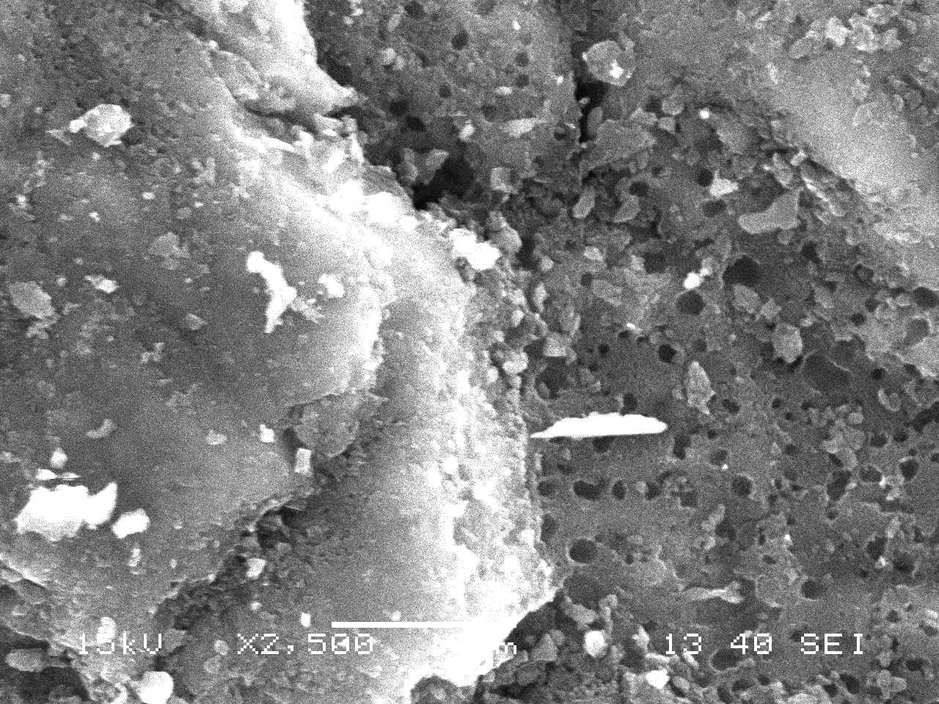

Fig.6.2 SEM photography of Iron impregnated activated carbon ( coconut-shell)

39 | P a g e

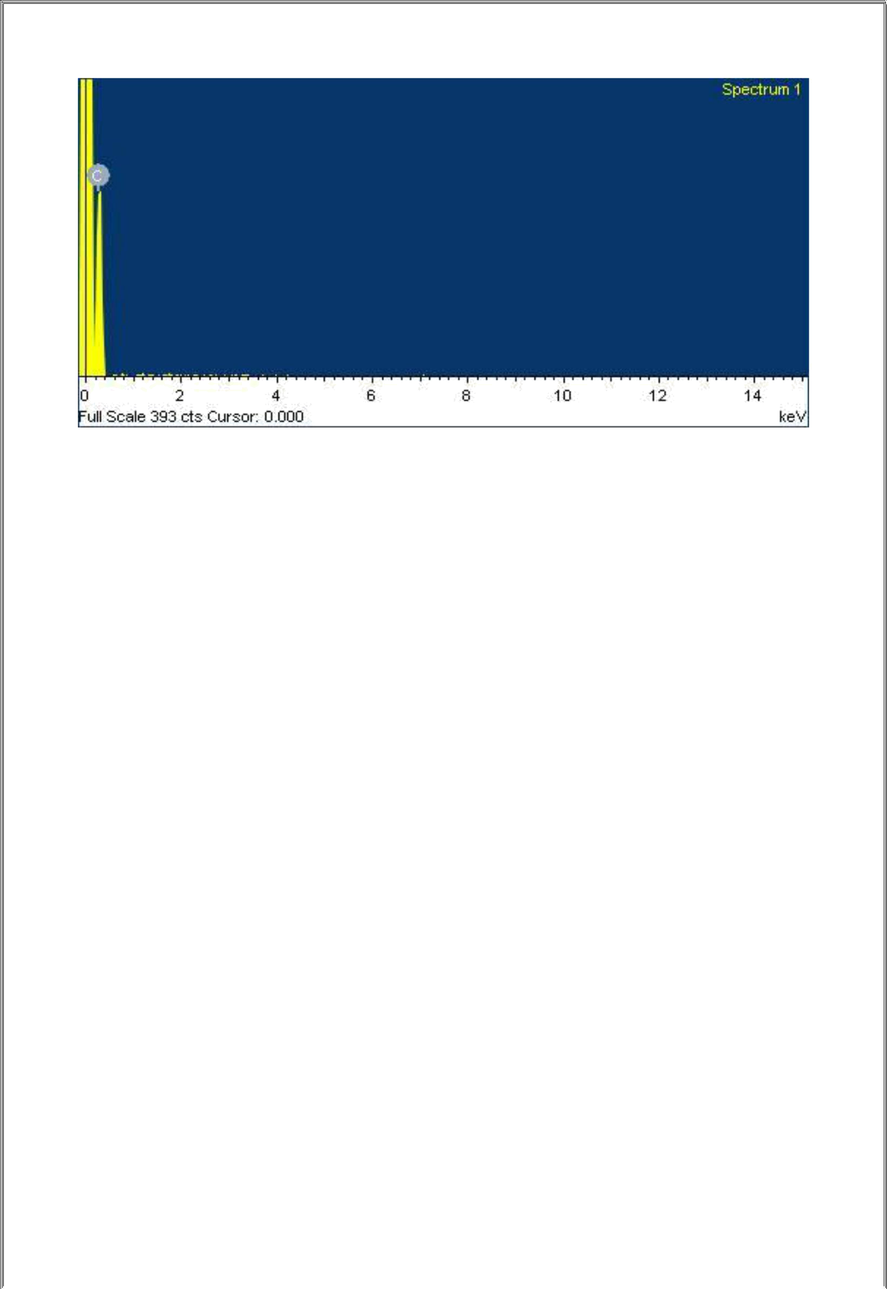

Fig.6.3 SEM analysis of presence of chemical component in activated carbon (coconut-shell)

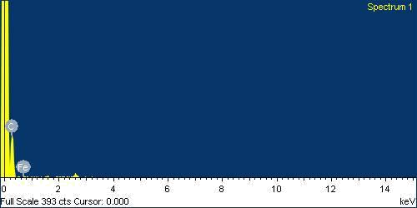

Fig.6.4 SEM analysis of presence of chemical component in iron impregnated activated carbon (coconut shell).

Figs. 6.1 and 6.2 show the SEM (2500X magnification) and EDX analysis of Fe-AC and Figs.6.3 and 6.4 shows the important physical parameters and major chemical components of the Fe-AC adsorbent. The EDX analysis delivers valuable evidence on the distribution of active metal in the structure based on carbon and shows the presence of Fe on surfaces of activated

40 | P a g e

carbon.So these evidences confirm that the whole procedure is a suitable method for coating

of iron on surface of activated carbon.

6.2 Iodine value, BET surface area , total pore volume of GAC and Fe-GAC:

The estimate iodine value, BET surface area, total pore volume and micropore volume are given below in the table.

Table.2 Physical properties of GAC and Fe-GAC

Property | GAC | Fe-GAC
Fe content,% (w/w) | 0 | 5
pHzpc | 6.92 | 6.6
BET-surface area, m²/g | 832 | 814
Toatal pore volume,cc/g | 0.624 | 0.512
Micropore volume | 0.537 | 0.449
Microporosity % | 86.05 | 87.6
Iodine value | 789 | 760

In the above data it is shown that the value of surface area,total pore volume,micropore volume

and iodine number of Fe-GAC is lesser than GAC.

41 | P a g e

6.3 The sorption isotherm:
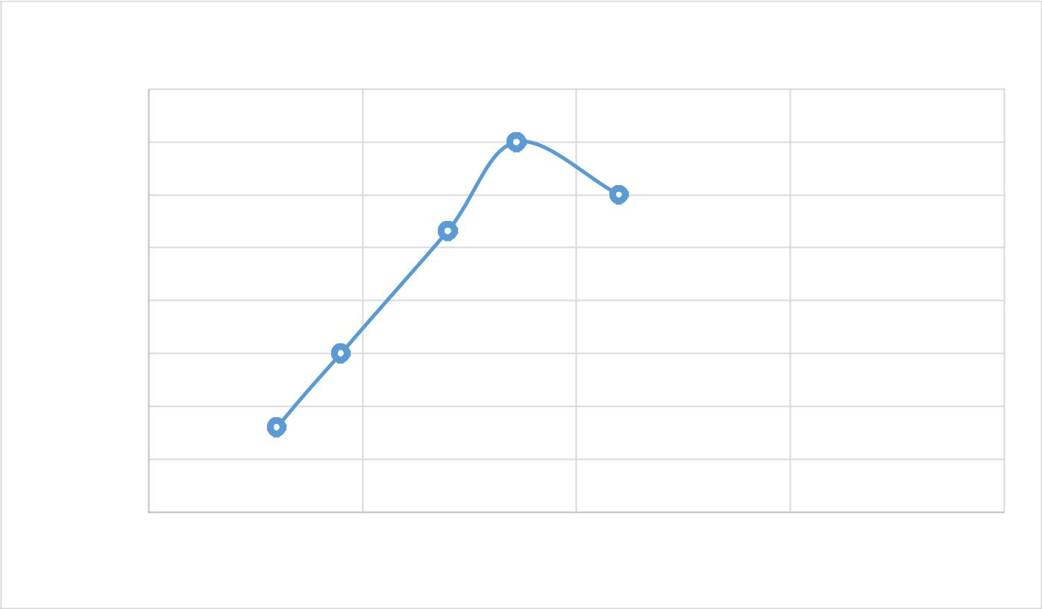

Qe

QE

0.001

0.00095

0.0009

0.00085

0.0008

0.00075

0.0007

0.00065

0.0006

0.1 0.15 0.2 0.25 0.3

CE

Fig.6.5 Experimental and theoretical qe versus Ce plots for the As(v) on Fe-AC


Ce/Qe

CE/QE

190
170 | y = 130.62x + 171.98
150 | R² = 0.5696

130

110

90

70

50

0 | 0.02 | 0.04 | 0.06 |  | 0.08 | 0.1 |  | 0.12 | 0.14 | 0.16 | 0.18 | 0.2
 |  |  |  |  |  |  | CE
 |  |  |  |  | Ce/Qe |  | Linear (Ce/Qe)

42 | P a g e

Fig.6.6 Langmuir isotherm for As(v) adsorption
 |  |  |  |  |  | log Qe
 |  |  |  |  |  |  |  |  |  |  | -3
-1 |  | -0.9 | -0.8 | -0.7 | -0.6 | -0.5 | -0.4 | -0.3 | -0.2 | -0.1 | -3.02 | 0
 |  |  |  | y = 0.8539x - 2.4002 |  |  |  |  |  |  | -3.04
 |  |  |  |  | R² = 0.993 |  |  |  |  |  | -3.06
QE |  |  |  |  |  |  |  |  |  |  | -3.08
LOG |  |  |  |  |  |  |  |  |  |  | -3.1
 |  |  |  |  |  |  |  |  |  |  | -3.12
 |  |  |  |  |  |  |  |  |  |  | -3.14
 |  |  |  |  |  |  |  |  |  |  | -3.16
 |  |  |  |  |  | LOG CE |  |  |  |  | -3.18
 |  |  |  |  | log Qe |  | Linear (log Qe)
Fig.6.7 Freundlich isotherm for As(v) adsorption
 | 100 |  |  |  |  |  |  |  |  |  | 0.6
 | 90 |  | 0.52
 |  |  | 0.52 |  |  |  |  |  |  |  | 0.5
 | 80 |  |  | 0.49 |  |  |  |  |  |  | mg/l
 |  |  |  | 0.46 | 0.44
 | 70 |  |  |  | 0.44
 | 70 |  |  |  |  |  |  |  |  |  | 0.4
% | 60 |  |  |  |  | 0.37
% | 50 |  |  |  |  |  | 0.33 |  |  |  | 0.3
% | 50 |  |  |  |  |  | 0.3 |  |  |  | 0.3
% |  |  |  |  |  |  |  |  |  |  | concentration
Removal | 40
Removal | 30 |  |  |  |  |  |  |  |  |  | 0.2
Removal | 30 |  |  |  |  |  |  |  |  |  | Residual
 | 20 |  |  |  |  |  |  | 0.13 | 0.13 | 0.13 | 0.1
 | 10
 | 0 |  |  |  |  |  |  |  |  |  | 0
 | 0 |  | 50 | 100 |  | 150 | 200 | 250 | 300 |  | 350
 | 0 |  | 50 | 100 |  | 150 | 200 | 250 | 300 |  | 350
 |  |  |  |  |  | Axis Title
 |  |  |  |  |  | Time in minutes
 |  |  |  |  | Removal % |  | Residual conc.
43 | P a g e

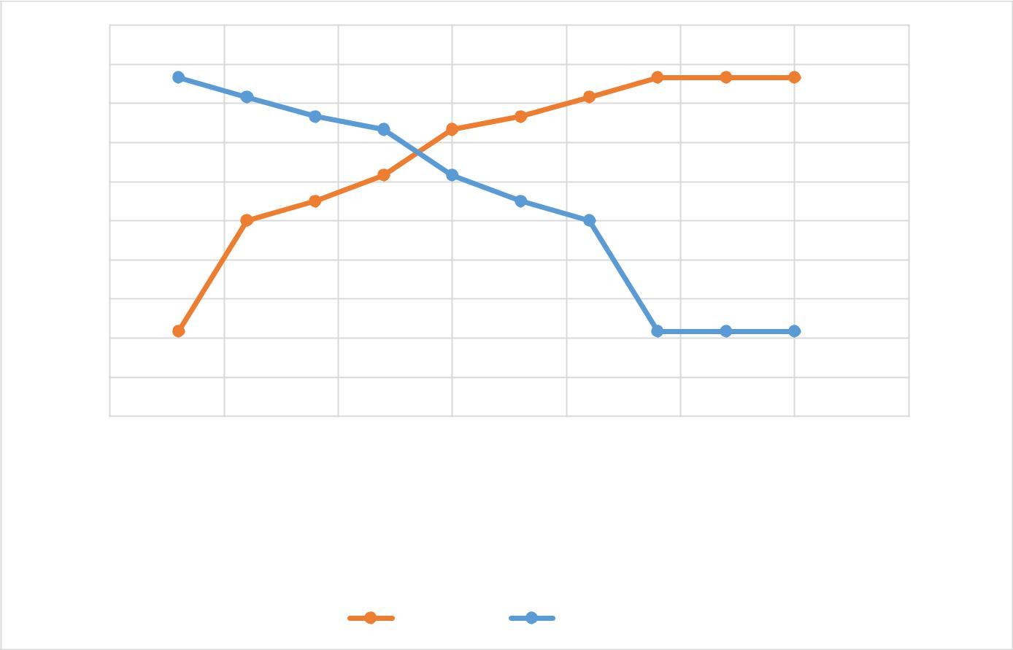
Fig.6.8 Removal efficiency of As(v), C0= 0.6 mg/L, Fe-AC dose=10mg/L
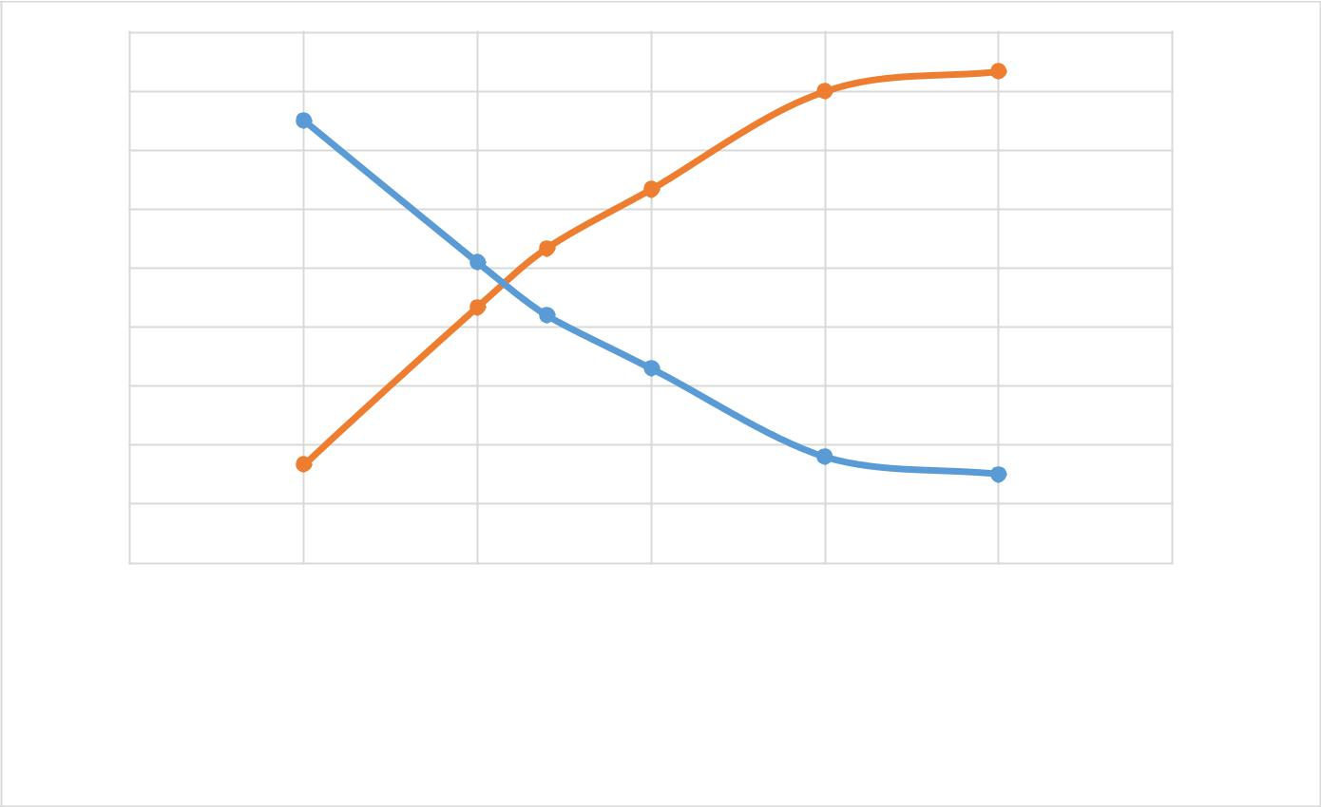

Removal %

90 |  |  |  |  |  | 0.3
80
 |  |  |  |  |  | 0.25
70 |  |  |  |  |  |  | concentration
60 |  |  |  |  |  | 0.2 | concentration
50
 |  |  |  |  |  | 0.15
40 |  |  |  |  |  |  | Residual
30 |  |  |  |  |  | 0.1 | Residual
20
 |  |  |  |  |  | 0.05
10
0 |  |  |  |  |  | 0
0 | 5 | 10 | 15 | 20 | 25 | 30
0 | 5 | 10 | 15 | 20 | 25 | 30

Adsorbent dose mg/l

 Removal %  Residual Conc.

Fig.6.9 Effect of adsorbent dose for As (v) removal, contact time=240min, C0=0.3 mg/L

The results of experimental isotherms carried out at ambient temperature are presented in Fig. 6.5. It can be seen that adsorption isotherm exhibits an L shape. In this classification, type L assumes monolayer formation in the active sites of the surface of carbon and all the adsorption sites are supposed to be equivalent.

Figs. 6.6 and 6.7 shows the observed (symbols) and simulated (lines) isotherms for the Fe-AC adsorbent. Comparisons between R2 in these models show that the adsorption of As(v) has a compliancy with Langmuir adsorption model (R2 = 0.5696 versus 0.993).

Removal efficiency and effect of adsorbent dose:

Fig. 6.8 shows the effect of contact time (0-300 min) on the adsorption of As(V). Adsorption efficiency increased with increase in contact time upto 240 min and a maximum removal efficiency of 86 % was attained and remained relatively constant (300 min). This study showed

44 | P a g e

that most of the removal (61%) occurred in the contact time of 120 min. In Fig. 6.9 it shown that, decreasing of As concentration to 0.05 mg/L and increase of Fe-AC upto 20 gm/L.

Analysis of filtrate collected from cartridge model:
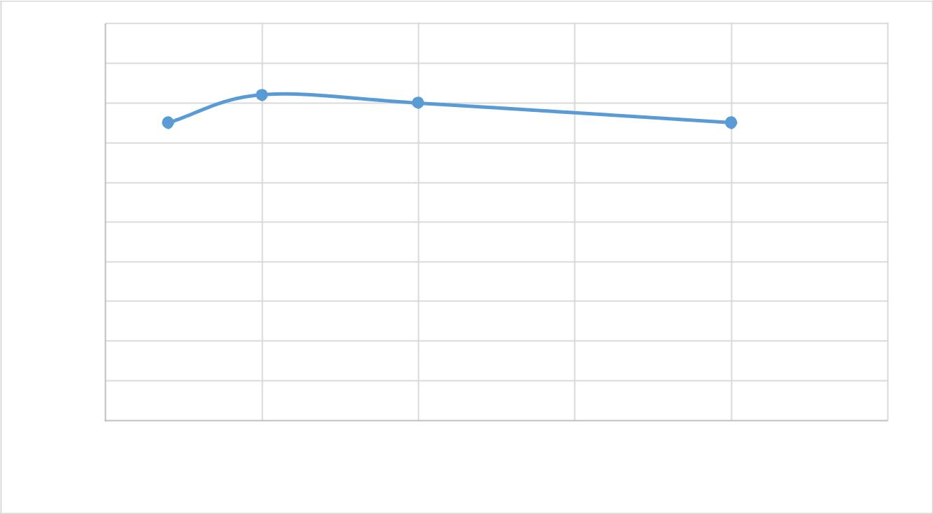

Removal %

100

90

80

70

60

50

40

30

20

10

0

0 0.005 0.01 0.015 0.02 0.025

Adsorbent dose mg/l

Fig.6.10 Removal efficiency of As(V) by modelled cartridge
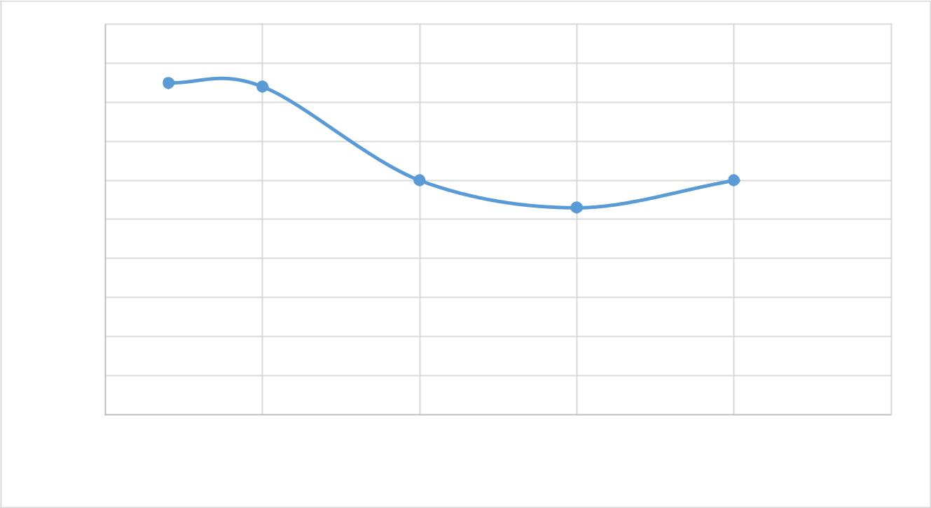

Removal %

100

90

80

70

60

50

40

30

20

10

0

0 0.05 0.1 0.15 0.2 0.25

Adsorbent dose

Fig.6.11 Removal efficiency of Fe by modelled cartridge

45 | P a g e

The above study shows promising results for the removal of iron and arsenic by the designed cartridge model. Removal percent is more when the adsorbent dose is less.

46 | P a g e

CHAPTER 7

CONCLUSIONS AND

FUTURE SCOPE OF STUDY

47 | P a g e

7.1 Conclusions

The conclusions from this present study summarizes as follows:

  - This study indicates that efficient granular activated carbons can be obtained from coconut shell from near locality. Coating of iron into activated carbon, also resulted in efficient adsorbent.

  - The surface texture of the Fe-GAC was shown that the Carbon material having microspores show it can effectively more surface area which adsorbed the heavy metals by SEM analysis.

  - The designed model was able to remove up to 82% of arsenic. Model having GAC materials characteristics Surface area of 832 m²/g, pore volume of 0.624 cc/g and pH of 6.92.

  - It is shown that the affinity of iron upto 86% removed well for characteristics Fe-GAC having Surface area of 814 m²/g, pore volume of 0.512 cc/g and pH of 6.6.

  - From the batch adsorption test it is shown that the iron impregnation activated carbon performs better for the adsorption for arsenic.

  - The measured sorption capacity of all amendments was greater than for GAC and Fe-GAC. For all arsenic solutes samples, GAC exhibited the highest adsorptive capacity, followed by adsorbent available in locally. GAC Exhibited strong competitive sorption effects between Iron and Arsenic present in the domestic drinking water supply.

- Future scope of study:

  - Many studies have been done in the field of cost efficient filtration technique.

48 | P a g e

- This study mainly focused on removal of iron and arsenic. In the future research, removal of other toxic material could be removed from drinking water.

- Other chemicals could be used in the method of impregnation onto the activated carbon and results could be seen.

49 | P a g e

REFERENCES

- Mlilo, T. B., Brunson, L. R. and Sabatini, D. A. (2010). “Arsenic and Fluoride Removal

Using Simple Materials”, Journal of Environmental Engineering , Asce

- Yu, T., Wang, X. and Li, C. (2014). “Removal of Antimony by Fecl3-Modifiedgranular-Activated Carbon in Aqueous Solution”, Journal of Environmental Engineering , Asce

- Fang, X., Xu, X., Wang, S. and Wang, D (2013). “Adsorption Kinetics and Equilibrium of Cu(Ii) from Aqueous Solution by Polyaniline/Coconut Shell–Activated Carbon
Composites”, Journal of Environmental Engineering , Asce

- Sewwandi, B. G. N., Vithanage, M., Wijesekara, S. S. R. M. D. H. R., Mowjood, M. I. M., Hamamoto, S. and Kawamoto, K. (2014). “Adsorption of Cd(Ii) And Pb(Ii) Onto Humic Acid–Treated Coconut (Cocos Nucifera) Husk”, Journal of Environmental Engineering , Asce

- Vaughan, R.L., Jr.,V. and Reed, B.E. (2005). “Modeling As(V) removal by a iron oxide impregnated activated carbon using the surface complexation approach”, Usa.

- Chen, W., Parette, R., Zou, J., Cannon, F. S. and Dempsey, B.A. (2007). “Arsenic

Removal by Iron-Modified Activated Carbon”, Department Of Civil And

Environmental Engineering, The Pennsylvania State University, 212 Sackett Building, University Park, Pa 16802, Usa.

- Mondal, P., Majumder, C.B. and Mohanty, B. (2006). “A laboratory study for the treatment of Arsenic, Iron, and Manganese bearing ground water using Fe3+ impregnated activated carbon: Effects Of Shaking Time, Ph And Temperature”,

Department Of Chemical Engineering, Indian Institute Of Technology Roorkee, Roorkee 247667, Uttranchal, India.

50 | P a g e

- Zhang, Q.L., Lin, Y.C., Chen, X. and Gao, N.Y. (2007). “A Method For Preparing Ferric Activated Carbon Composites Adsorbents to Remove Arsenic From Drinking

Water”, Journal Of Hazardous Materials 148 (2007) 671–678, China.

- Krczil, F. (1937). “ Production of Activated Carbon”, United States Patent Office, Czechoslovakia.

- Watanabe,Y. and Miyajima,T.(1977). “Process For Producing Granular Activated Carbon”, United States Patent, Tokyo, Japan.

- Jusoh, A.B., Cheng, W.H., Low, W.M., Nora’aini, A. and Noor, M.J.M.M. (2005).

“Study on the removal of Iron and Manganese in Groundwater by Granular Activated

Carbon”, Department Of Engineering Science, Faculty Of Science & Technology,

Kolej Universiti Sains & Teknologi, Malaysia, 21030 Kuala Terengganu, Terengganu.

- Chang, P.Y., Wei, Y.L., Yang, Y.W. and Lee, J.F. (2003). “ Removal of Copper from

Water By Activated Carbon”, Taiwan, Republic Of China.

- Yusof, A. M., Rahman, M. M. and Wood, A. K. H. (2006). “Adsorption of Some Toxic Elements From Water Samples On Modified Activated Carbon, Activated Carbon And

Red Soil Using Neutron Activation Analysis” , Journal Of Radioanalytical And Nuclear Chemistry, Vol. 271, No.1 (2007) 191–197, Malaysia.

- Astm Journal D4067-14 “Standard test method for determination of iodine number of activated carbon”.

- Leede,R.P.D., Staal,E.G.J., Rodgers,M., and Reimerink-Schats,W.M.T.M. (2014).

“Chemically Activated Carbon And Methods For Preparing Same”, United State

Patents.

- Robinson, K.K. (1990). “Granulated Activated Carbon for Water Treatment”, United

State Patents.

51 | P a g e

- Tolles, E.D., Dimitri, M.S. and Matthews, C.C. (1993). “High Activity, High Density Activated Carbon”, United State Patents.

- Ghanizadeh, G., Ehrampoush, M.H. and Ghaneian, M.T. (2010). “Application of iron impregnated activated carbon for removal of arsenic from water”, Iran.

- Knobloch,J.O. and Malo, R.V.(1965). “Removal of metal contaminates from activated carbon” Munster, Lnd, Assignors To Standard Oil Qompauy, Chicago.

- Crewe., A. V. (1965). “Scanning Electron Microscope”, Palos Park, Ill., Assigner To The United States of America As Represented By The United States Atomic Energy Commission.

- Joyce,R.S. and Pittsburgh, Pa.(1965). “Removal of Iron from Water”, United States

Patent, Assignor To Pittsburgh Activated Carbon Company, Pittsburgh, Pa., A Corporation Of Pennsylvania.

- Farris,T.S., Coe,C.G., Armor,J.N. and Schork, J.M. (1992). “High Capacity Coconut Shell Char for Carbon Molecular Sieves”, United States Patent.

- Wagh, D.D., Arabale, G.V., Kulkarni, M.P., Mulla, I.S., Kunjukrishanapillai, V., Vernekar,S.P.,Jha, R.K. and Jacob, N.E. (2010). “Process for Preparing High Surface

Area Carbon”, United States Patent.

52 | P a g e

