Trade-offs between the water supply and healthy of Red River in Vietnam
Fellow: Nguyen Duc Viet - Directorate of Water Resources, MARD Vietnam.
Mentor: Dr. Dao Trong Tu - Centre for sustainable development of water resources and adaptation to climate change (CEWAREC).
WEBSTORY
1. Red river and Red River Delta
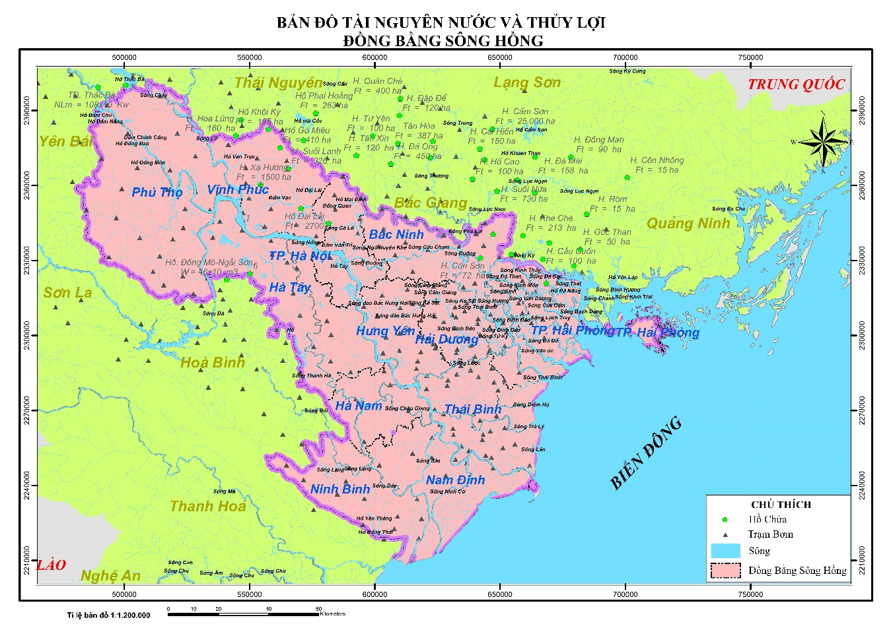
Rivers have played an important role in the economics society development of human life. Since thousands of years, before the irrigation system exist (dykes, dams, canals, etc.), many delta regions have been formed naturally by the floodplains of the rivers. And, the Red River Delta (RRD) is one such delta.
Figure 1: Map of water resources and hydraulic works of RRD
Source: Viet.ND (MARD) and Thang.TN (IWE), 2015
RRD is a vast land area located downstream of the Red River in the Northern of Vietnam, area approximately 23,336km², account for 7,1% Vietnam's area.
Red River is like “blood vessel" of the economic development of whole the RRD.
Red River has a length of 1,149 km derived from Yunnan Province, China; it flows through the territory of Vietnam before emptying into the East Sea, in which, length of the Red River in the territory of Vietnam is about 328 km. According to MONRE Vietnam, Red River Basin (RRB) is approximately 169,020 km², of which 81,240 km² (48%) in China’s territory, 1,100km² (0.65%) in Laos and 86,660km² (51.35%) in Vietnam.
The total amount of water of the Red River flowing to the territory of Vietnam has been estimated at about 82.54 bill.m³/year (IWRP 2015), it carries a large amounts of sediment estimated about 125 million tons / year (VAWR 2010), that has greatly contributed to the development of agriculture production of RRD.
2. The status quo of water use in the Red River Basin
According to three study researches: (i) Project 1: planning using integrated water Red River Basin (IWRP 2007); (ii) Project 02: scientific basis and operating practices for water supply in dry season of RRD (WRU 2008); (iii) Project 03: 2nd Red River Basin (ADB3 2005) regarding water demand of economic sectors of the RRB in the territory of Vietnam, phase 2010-2020 as follows:
Table 2.1. Water demand of economic sectors in the RRB
No. | Water demand project forecast to 2020 | Project 01 | Project 02 | Project 03
A | Demands
1 | Agriculture | 11.70- 13.60 bill.m³/year | 13.70 bill.m³/year
2 | Water supply | 0.98- 1.23 bill.m³/year | 1.16 bill.m³/year
3 | Industry, handicraft villages | 0.31- 0.51 bill.m³/year | 0.06 bill.m³/year
4 | Livestock | 0.18- 0.35 bill.m³/year | 0.46 bill.m³/year
5 | Aquaculture | 7.04- 7.70 bill.m³/year | 1.07 bill.m³/year
6 | Deacidification, desalination | 0.50- 0.60 bill.m³/year | 0.08 bill.m³/year
 | Total A | 20.71- 23.69 bill.m³/year | 24.80 bill.m³/year | 25.3 bill.m³/year
B | Water demand to ensure the Red River health
1 | Environmental flow (15% A) | 3.11- 3.55 bill.m³/year | 2.47 bill.m³/year | 3.80 bill.m³/year
These results show that total water demand of the economic sectors in RRB in Vietnam by 2020 is estimated at 23 bill.m³/ year of that 81- 98% for RRD (IWRP 2007).
3. The challenges to ensure the water supply
In comparison with water demand of other sectors, water demand of agriculture production is largest; it is about 13.65 bill.m³/year, accounted for 16.4% of total annual flow generated of the Red River in Vietnam.
Regarding to the infrastructures for agriculture, RRD has 3,488/ 5,415 irrigation pumping stations (MARD 2014); and 61,258 km canal water distribution and a thousands of gates or intakes along the Red River.

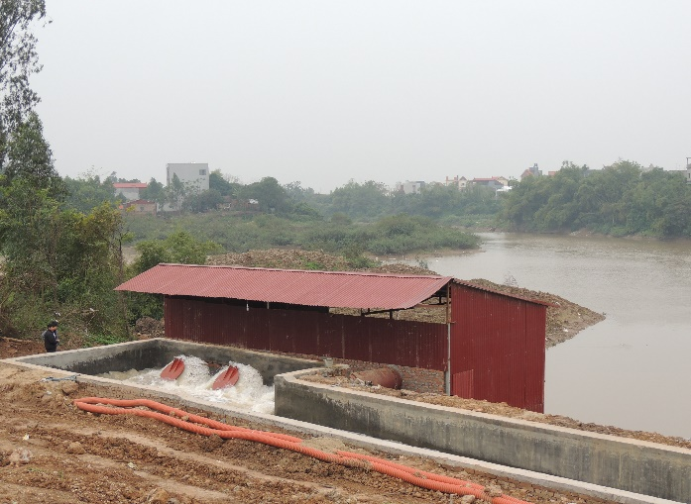  Figure 3.1. The Yen Phu pumping station in Bac Ninh province | 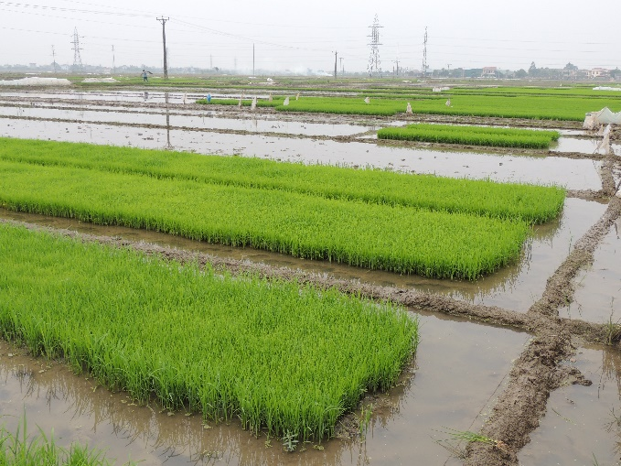  Figure 3.2. The rice-field in Hai Duong province
Source: Viet. ND, 2016
However, effectiveness of hydraulic works has not yet achieved as original designs due to some reasons:
- Most of hydraulic works have been built about 40 years ago, therefore, these works has now been degraded over time.
- Poor management of Irrigation and Drainage Management Companies (IDMC).
- Lack of budgets to upgrade, repair and maintenance the hydraulic works.

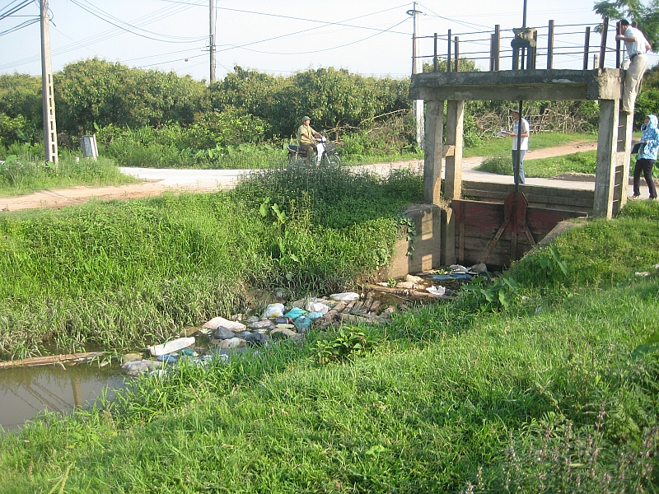
Figure 3.3. The degradation of hydraulic works in Nam Dinh province
Source: Viet. ND, 2014
At the present time, the efficiency of water irrigation system of RRD is approximately around 60% (MARD 2014); if so, forecast to in 2020, the Red River needed to be supplied amount of water is about 21.5 bill.m³/year, increase flow by about 8 bill.m³/year compared to actual demand (13.65 bill.m³/year).
4. Trade-offs between the water supply and the healthy river
Assumption 01: concerning only on one side of water supply
To meet the increasing water demand for agriculture production and other economic sectors by 2020, hydraulic works will have to receive more water from the Red River, this trade-offs would be a negative impact of the Red River health. Why?

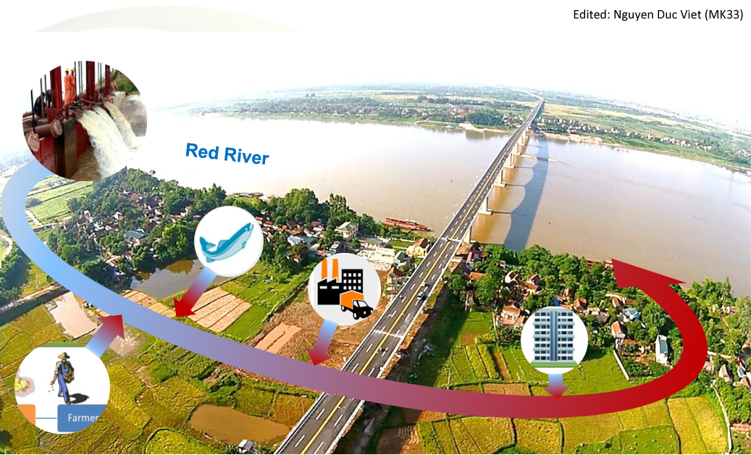
Figure 4.1. Impact of human activities on water quality of the Red River
Continued from analyzing as mentioned above, not all the irrigation water will be "disappear" completely, after being used partly for human productive activities, especially agriculture production, majority of irrigated water will be back to the Red River by many ways, such as via the drainage canals or groundwater. Unfortunately, most irrigation supplies contain very high concentrations of these toxic and are generally quite big problems, which are the water quality and salinity intrusion, namely:
- The water quality: after water is used in the irrigated lands, it will drain back the Red River, and irrigated water carries a lot of the residual of plant protection products, fertilizer on the field, waste discharge from handicraft villages, industry parks, etc.; in consequence, poor water quality and pollution have negative impact on ecological characteristics of the Red River.
- The salinity intrusion: use more water for irrigation systems along the Red River leads to lack of water to push salinity in the estuaries, so the combined effects of salinity intrusion and sea level rise (due to climate change) resulted in degradation of coastal ecosystems.

Assumption 02: concerning only on one side of Red River health
Frankly, there is an assumption, many environmental protection agencies of Government and NGOs will protest, therefore, this trade-off usually involves the irrigation systems will have to use less water from the Red River, in consequence, not getting enough water to service agriculture production and other economic sectors lead to impact on development of RRD.
5. In lieu of a conclusion
- In a nutshell, due in part to the degrading quality of hydraulic work systems, water supply for agriculture production will increase dramatically in 2020 approximately 8 bill.m³/year compared to actual demand is about 13.65 bill.m³/year. And, more irrigation water may be more harmful for the Red River health.
- That is absolutely correct in the context of the hydraulic works not only provide irrigation water for agriculture production, which also supply for other economic sectors such as industry, drinking water, aquaculture farms , etc.
- Therefore, to harmonize the benefits between the sustainability of water supply and the Red River health, one of the approaches to solve these problems, which is improving the water use efficiency of hydraulic works in RRD including: (i) hardware is the quality of the hydraulic works; (ii) software is the irrigation governance.
Hanoi, January 23, 2016

